App name: Duolingo: Learn Languages Free

- description:
Learn Spanish, French, German, Italian, Russian, Portuguese, Turkish, Dutch, Irish, Danish, Swedish, Ukrainian, Esperanto, Polish, Greek, Hungarian, Norwegian, Hebrew, Welsh and English.
Totally fun and free. New! Swahili and Romanian.
Practice your speaking, reading, listening and writing skills while playing a game! You will improve your vocabulary and grammar skills by answering questions and completing lessons. Start with basic verbs, phrases, and sentences, and learn new words daily.
Google Play s Editor s Choice and Best of the Best of 2013 and 2014!
Far and away the best language-learning app. The Wall Street Journal
Duolingo may hold the secret to the future of education. TIME Magazine
Among apps for learning a language, you can not beat Duolingo. PC Magazine.
The most productive means of procrastination ever discovered. The short lesson blocks are painless and peppy, and reaching the next level (and then the level after that) becomes addictive. Slate
Duolingo is changing the way people learn languages.
It is free, for real.
It is fun. Advance by completing bite-sized lessons, and track your progress with shiny achievements.
It is effective. 34 hours of Duolingo are equivalent to a semester of university-level education.
Send any feedback to android@duolingo.com

- The Goal Model
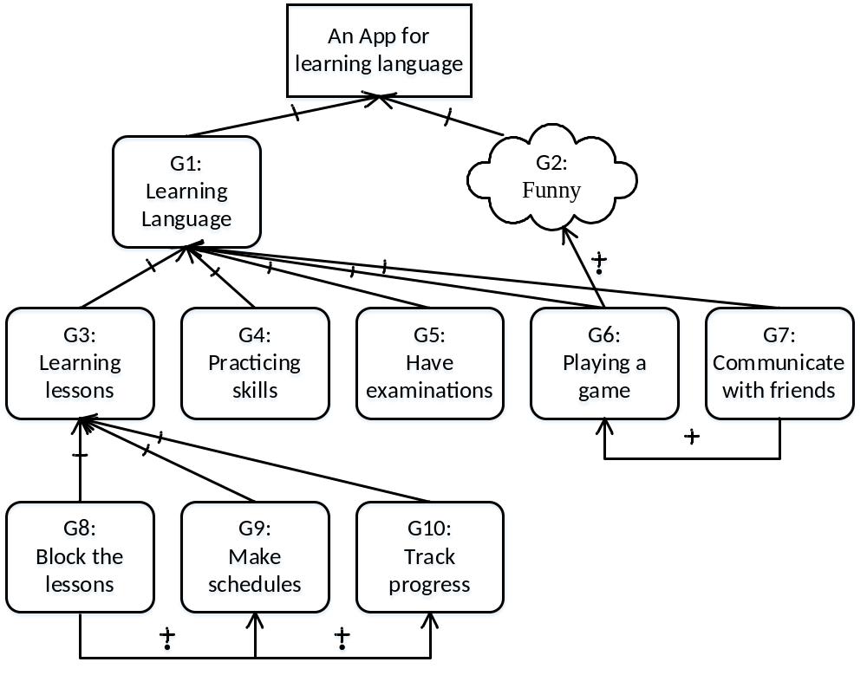
- The description of each goal

ID | Des | Type
G1 | Learning Language, including Spanish, French, German, Italian, Russian, Portuguese, Turkish, Dutch, Irish, Danish, Swedish, Ukrainian, Esperanto, Polish, Greek, Hungarian, Norwegian, Hebrew, Welsh, English, Swahili and Romanian | Hard goal
G2 | Funny, interesting, painless and peppy | Soft goal
G3 | Leaning lessons: basic verbs, phrases, and sentences, and new words | Hard goal
G4 | Practicing skills: speaking, reading, listening and writing skills | Hard goal
G5 | Have examinations for evaluating the level of ability | Hard goal
G6 | Playing a game | Hard goal
G7 | Communicate and share with friends | Hard goal
G8 | Divide the lessons into blocks | Hard goal
G9 | Make schedules for assigning the time according to users | Hard goal
G10 | Tracking the learning progress and discovering the achievements | Hard goal

